**Data changes to demonstrate Time Travel:**

*Initial record:*

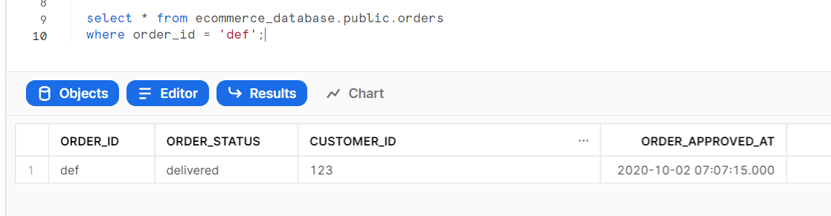

*Update statement:*

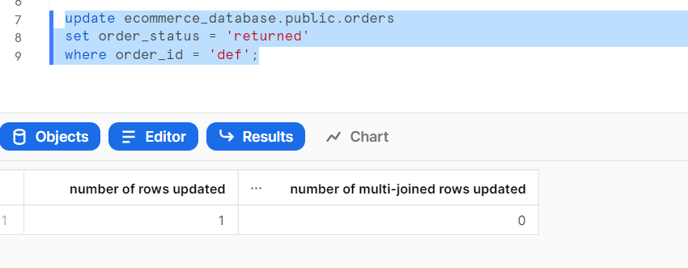

*Changed record:*

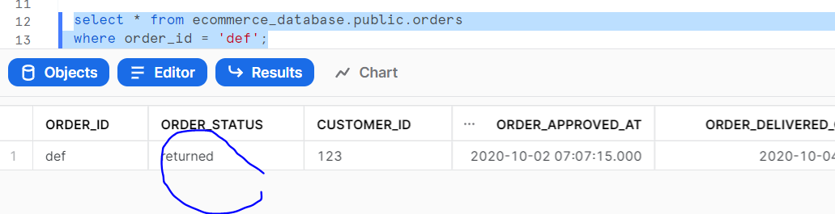

**Time Travel Option 1: Using offset.**

The value 30 minutes earlier:

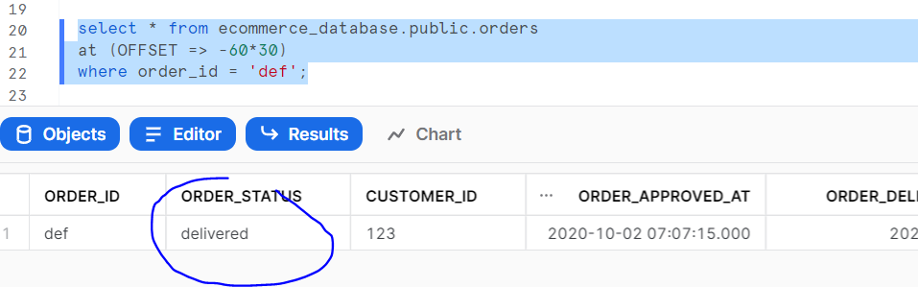

**Time Travel Option 2: The value at a certain time:**

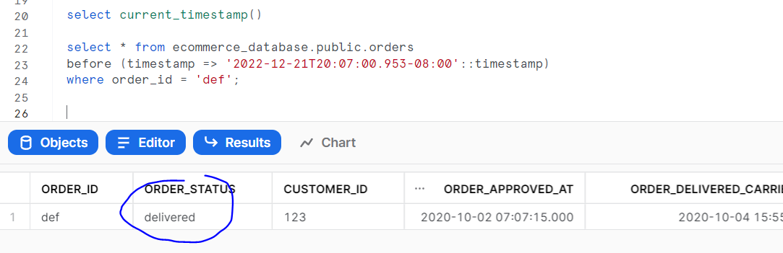

**Restoring the data:**

*Step 1:*

Consider a scenario where your table is corrupted and you want to rollback the data to a certain time. You can do this using time travel:

Create a backup table using time travel:

CREATE OR REPLACE TABLE ecommerce_database.public.orders_bkp as

SELECT * FROM ecommerce_database.public.orders

before (timestamp => '2022-12-21T20:07:00.953-08:00'::timestamp);

or

CREATE OR REPLACE TABLE ecommerce_database.public.orders_bkp as

SELECT * FROM ecommerce_database.public.orders

at (offset => -60*30);

*Step 2:*

After verification of data in the backup table, load this back into the main table:

TRUNCATE table ecommerce_database.public.orders;

Insert into ecommerce_database.public.orders

Select * from ecommerce_database.public.orders_bkp;

**Table Types and Time Travel:**

* Permanent tables:

Time travel retention period - 0 - 90 days, Fail safe up to 7 days

Fail safe is recovery beyond time travel and the recovery can be done only by snowflake support.

Use when data protection is absolutely critical

* Transient tables:

Data is available till table is dropped

Time travel retention period - 0 - 1 day, Fail safe not possible

Use when it is OK for data to be lost

* Temporary tables:

Data is available only in the session where it is created

Time travel retention period - 0 - 1 day, Fail safe not possible

Use for temporary processing, maybe as an intermediate table in a job

**Undrop:**

The Time Travel feature in Snowflake even enables us to un-drop tables / schema / tables that were earlier dropped for some reason.

UNDROP DATABASE ecommerce_database;

UNDROP SCHEMA ecommerce_database.public;

UNDROP table ecommerce_database.public.orders;